**Lesson 4 APP4**

**Container Scaling with Docker Swarm**

Creating service for scaling

**Please Note:** Docker containers deployed on Docker swarm cluster can be scaled up and down to implement high availability of Docker containers. If in case any Docker container gets crashed, we can get a new one created and other containers can easily handle the load.

* Use the commands below to create a service and scale the service up and down to increase or decrease Docker containers
* Initially 3 replicas are there

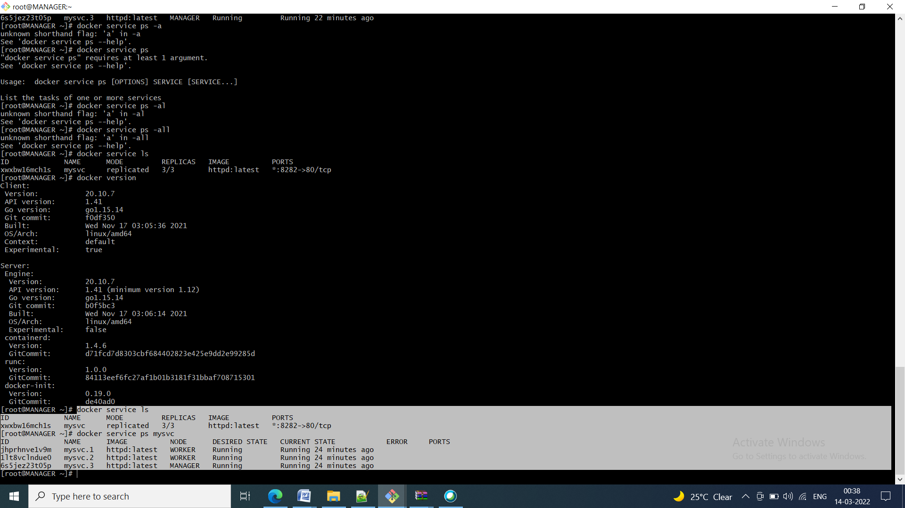

Scaling down the replicas to 2

docker service scale mysvc=2

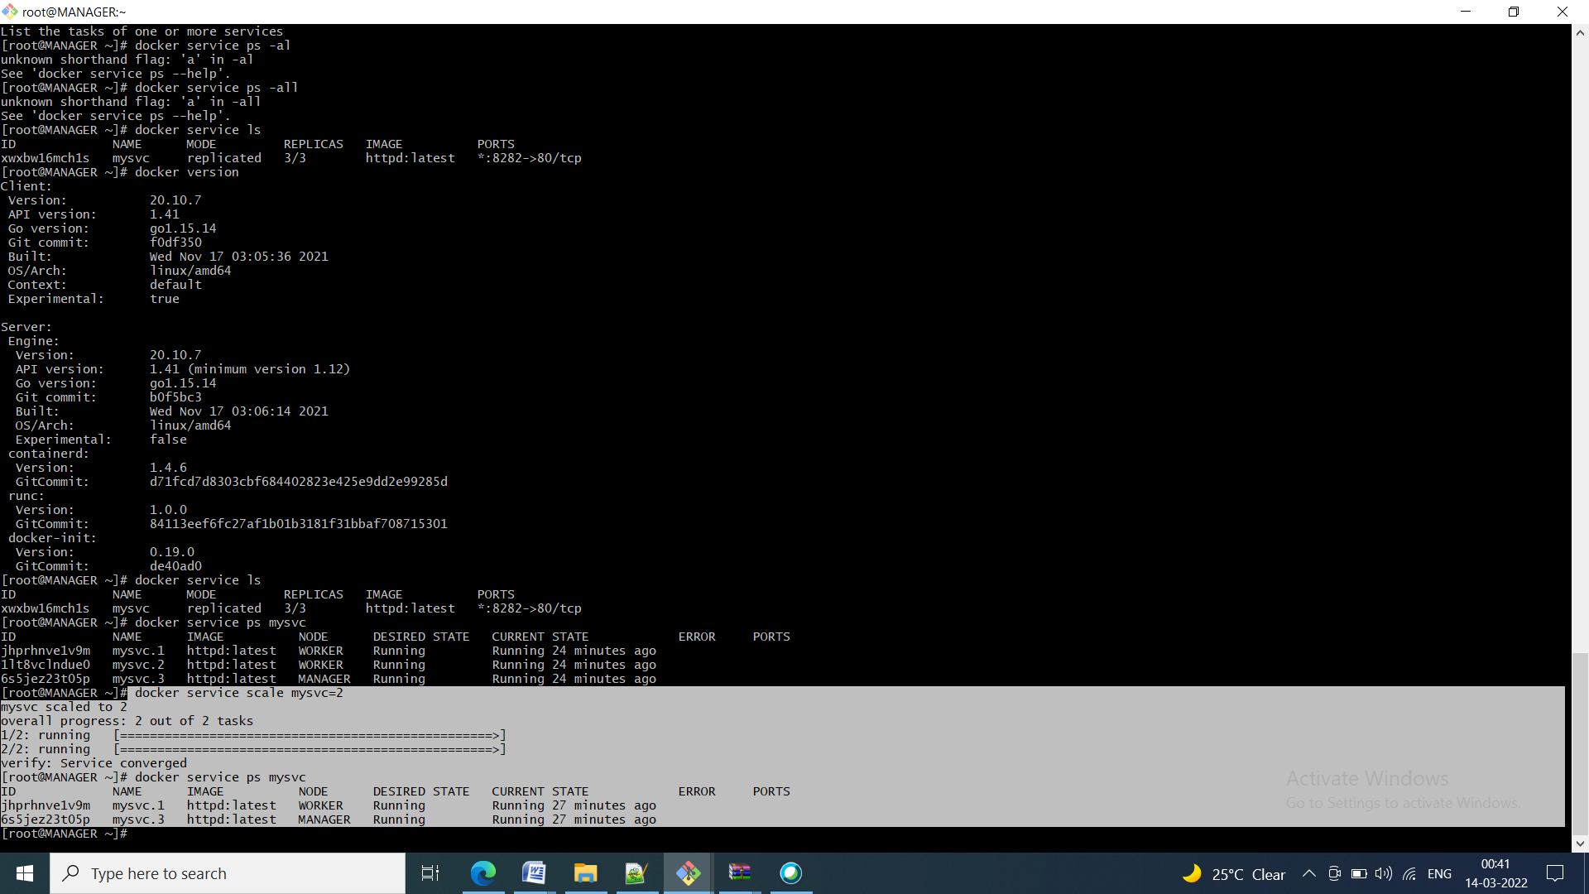

Now Scaling up the replicas to 6

docker service scale mysvc=6

